**GPS TRACKING MODULE COMPONENTS :**

**To implement the Neo-6 GPS module with an Arduino Uno in a toy model for GPS tracking, gather the following components first :**

COMPONENTS REQUIRED :

**CONNECTING COMPONENTS -**

**HARDWARE COMPONENTS -**

**3. ARDUINO UNO**

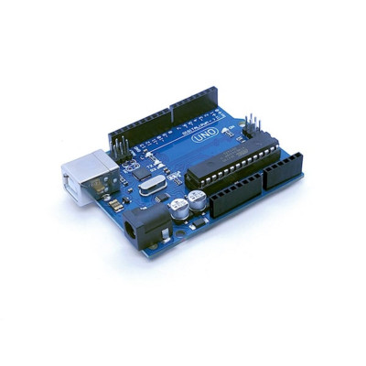

**4. NEO 6 GPS MODULE** 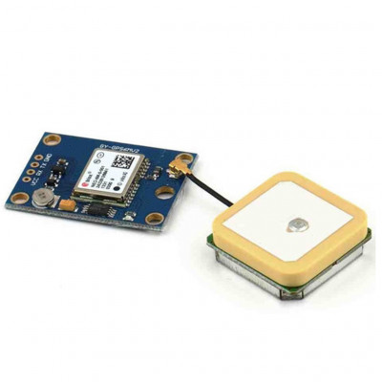

1. **JUMPER WIRES**

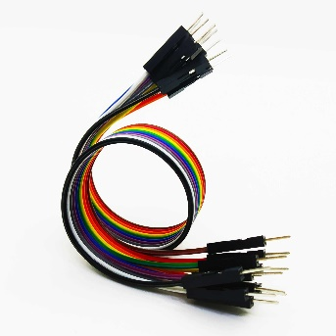

1. **JUMPER PINS**

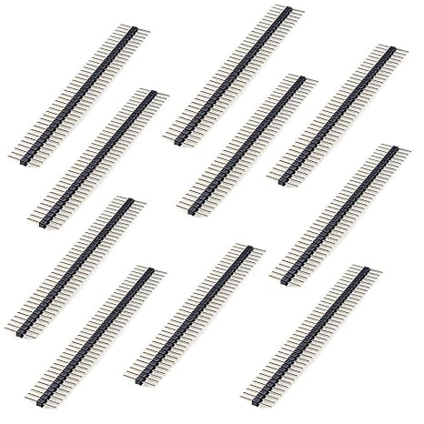

1. **ARDUINO USB CABLE**

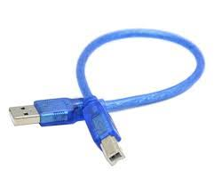

**SOFTWARE COMPONENTS :**

1. **ARDUINO IDE SETUP**



**SETUP INSTALL LINK : https://www.arduino.cc/en/software**

1. **“TINY GPS++ BY MIKEL HART” LIBRARY EXTENSION TO BE INSTALLED**

**LIBRARY EXTENSION LINK :**

[GitHub - neosarchizo/TinyGPS: A compact Arduino NMEA (GPS) parsing library](https://github.com/neosarchizo/TinyGPS)

**SUITABLE ENVIROMENT TO IMPLEMENT THE SETUP :**

1. WINDOWS
2. MAC OS